|  |  |  |  |
| --- | --- | --- | --- |
| **Student’s name** | …………………………………………………….…… | **Grade** | **3** |
| **Subject** | **Computer** | **Week No.** | **3** |
| **Lesson Title** | **Inside a Computer** | **Unit** |  |

**Worksheet No. ( 3 )**

**write the correct name of each part**.

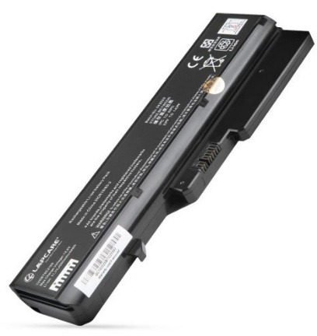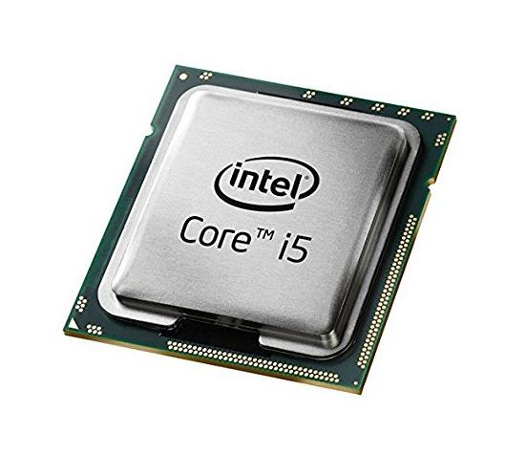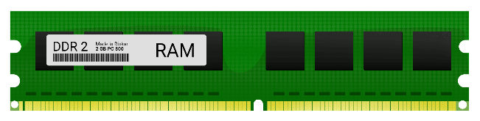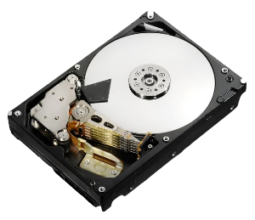

Battery Laptop

Hard Disk

RAM

**Good Luck**

CPU